Inventory Management in Magento 2

**1. Product Stock Options:**

* In Magento 2, each product has its own inventory settings.
* You can set whether a product is in stock or out of stock.
* Additionally, you can manage stock for each product individually or in bulk.

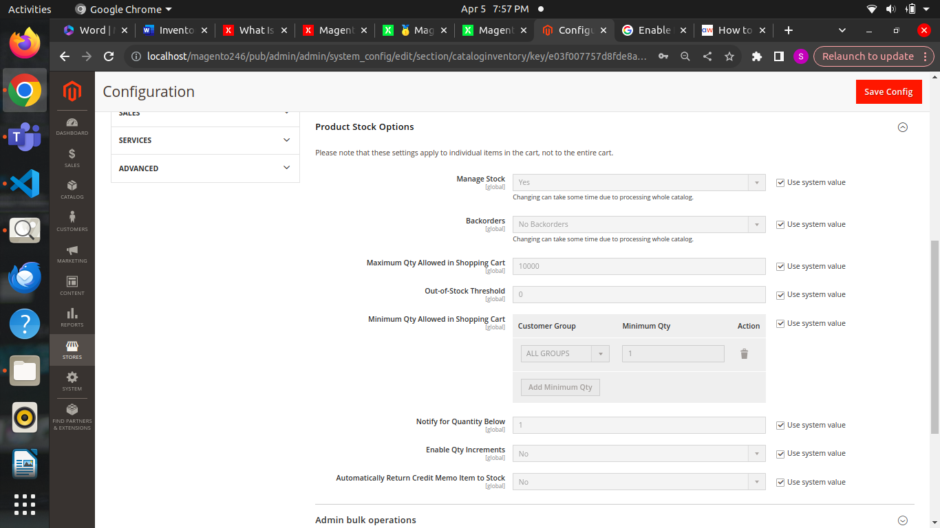

**Manage Stock** – this option is enabled by default and used to count products in stock. It can be disabled if you sell products that can’t run out of stock.

**Backorders** – enable this option to allow customers place orders of out-of-stock products.

**Maximum Qty Allowed in Shopping Cart** – sets the maximum number of products that can be placed in the shopping cart.

**Out-of-Stock Threshold** – you can set the minimum number of products to reach before the Out-of-Stock message should be displayed.

**Minimum Qty Allowed in Shopping Cart** – defines the minimum number of products required to place an order. You can set various limits for different groups of customers.

**Notify for Qty Below** – this option notifies you when the number of products in stock drops below the defined quantity.

**Enable Qty Increments** – allows you to set the quantity of a product in a single lot that you add to your stock.

**Automatically Return Credit Memo Item to Stock** – with this option enabled, products added to a cart automatically get an out-of-stock status and if they return back when an order is cancelled.

**2. Stock Status:**

* Magento 2 provides options to set stock status for products.
* Products can be marked as in stock, out of stock, or disabled when they are out of stock.

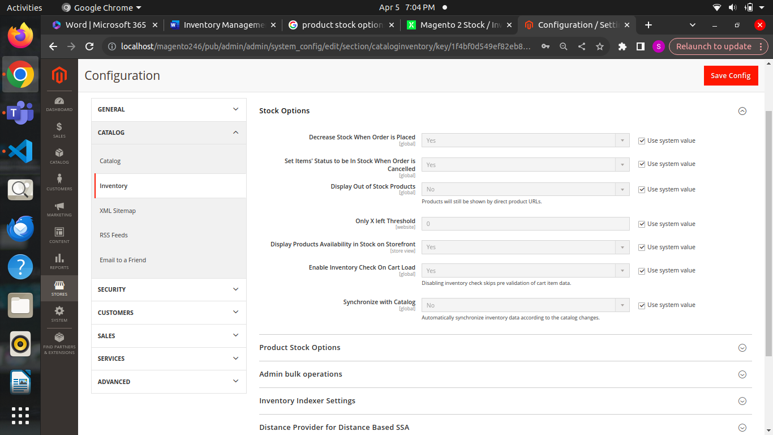

**Decrease Stock When Order is Placed** – enable to decrease a stock quantity of the product when an order is placed.

**Set Items’ Status to be in Stock When Order is Cancelled** – enable to place items from cancelled orders back in stock.

**Display Out of Stock Products** – hide to display products that are out of stock.

**Only X left Threshold** – adds a phrase ‘Only X products left’ to all your products, where X is the entered number. Also, you can configure this for each individual product. Hence, it may be better to leave this option equal to 0.

**Display products availability in Stock on Storefront** – enable to display a stock availability on product pages.

**3. Product Quantity:**

* You can set the quantity of each product available in stock.
* Magento 2 allows you to update product quantities manually or import them in bulk via CSV files.

**4. Stock Alerts:**

* Magento 2 enables you to set up stock alerts for low inventory.
* When inventory levels drop below a specified threshold, administrators can receive notifications.

**5. Backorders:**

* Magento 2 supports backorders, allowing customers to purchase products even when they are out of stock.
* Admins can specify whether backorders are allowed and set conditions for processing backordered items.

**6. Multi-Source Inventory (MSI):**

* Magento 2 introduces Multi-Source Inventory (MSI) for advanced inventory management.
* With MSI, you can manage inventory across multiple locations or warehouses.
* This feature enhances order fulfillment efficiency and allows for better inventory tracking.

**7. Warehouse Management:**

* MSI in Magento 2 facilitates the management of multiple warehouses or physical locations.
* You can assign products to specific warehouses and track inventory levels accordingly.
* Warehouse management streamlines order processing and improves shipping accuracy.

**8. Inventory Tracking:**

* Magento 2 provides robust tools for tracking inventory movements.
* You can monitor stock levels, sales, returns, and adjustments in real-time.
* Detailed reports offer insights into inventory performance and help optimize stock management.

**9. Product Bundles and Configurable Products:**

* Inventory management extends to product bundles and configurable products in Magento 2.
* You can track stock levels for individual components of bundles and configurations.
* This ensures accurate inventory management and prevents overselling.

**10. Third-Party Integrations:**

* Magento 2 offers integrations with third-party inventory management systems.
* You can sync inventory data between Magento and external platforms for seamless operations.
* Integrations enhance inventory visibility and streamline business processes.

**Store Pickup in Magento 2**

It turns your physical store into an extension of your online business. It allows customers to purchase items online and pick them up in person at a convenient location.

It’s a part of Magento’s [Order Management System](https://omsdocs.magento.com/getting-started/) (OMS), designed for customers who prefer shopping in-store but also want to limit contact. Also, it helps save on shipping costs and is particularly useful for items that are delicate and could get damaged during delivery.

**For customers:**

* **Faster product access:** Customers can complete their purchases swiftly and conveniently without the need to wait for deliveries.
* **Convenience and flexibility:** Customers can choose a pickup time that fits their schedule.
* **Reduced shipping costs:** Customers avoid additional charges associated with shipping, saving them money.
* **Increased satisfaction:** The seamless experience fosters positive brand perception and loyalty.

**For business:**

* **Boosted sales:** Drive more in-store traffic and convert online shoppers into physical customers.
* **Reduced shipping costs:** Save on packaging, fulfillment, and shipping expenses.
* **Improved inventory management:** Optimize stock levels based on store pickup demand.
* **Valuable customer data:** Gather insights into customer preferences and buying habits.

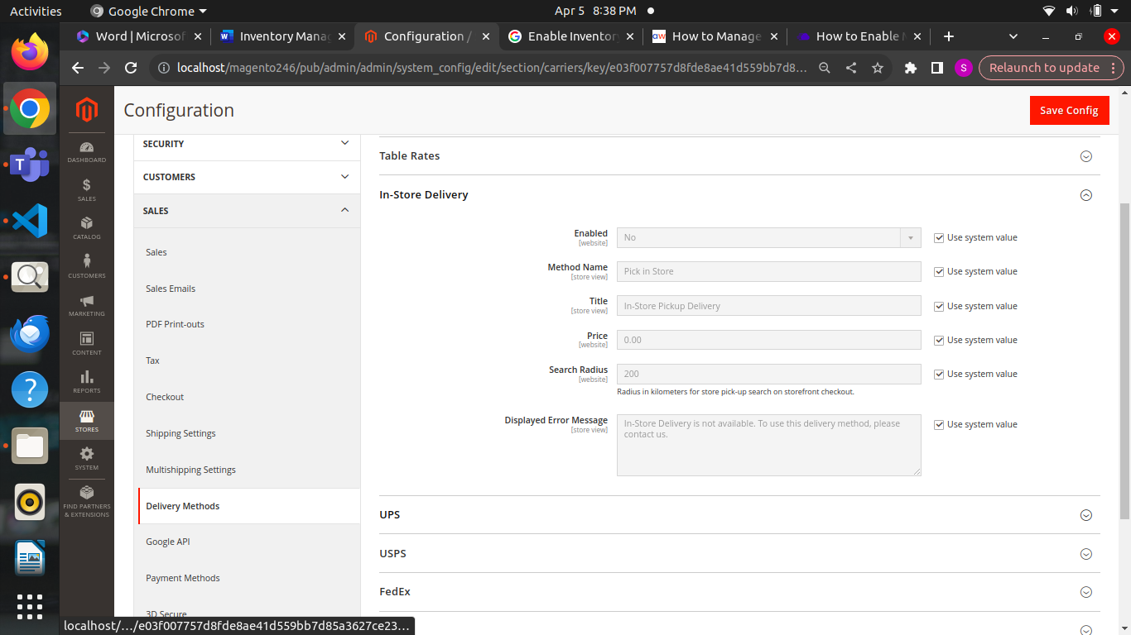

**Enabled:**

* to activate Store Pickup.

**Method Name:**

* Enter a **Method Name** that customers will see at checkout.

**Title:**

* Create a descriptive **Title** for this delivery method.

**Price:**

* Set a **Price** for Store Pickup if desired

**Search Radius:**

* **Search Radius** for displaying nearby stores during checkout.

**Displayed error message:**

* customize the **Displayed Error Message** shown when Store Pickup is unavailable